Real Rail Adventures: Switzerland
With Jeff Wilson

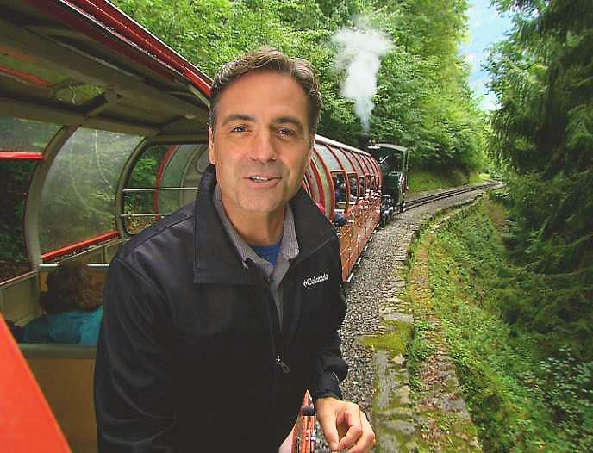
Real Rail Adventures: Switzerland host Jeff Wilson savors a train ride back in time on the Brienz-Rothorn Mountain Railway near Interlaken, Switzerland. In this hour-long public television documentary, Wilson crisscrosses a nation that reveres railroads. Jeff’s mission: discover why the Swiss—and countless others around the globe—love trains. He wonders, “Is it the adrenaline rush of big machines, surging against probability up a mountainside? Is it the thrill of exploration—the way trains slice through remote areas, giving up-close views of inaccessible landscapes? Maybe it’s the nostalgia, the echoes of a time gone.” Jeff concludes, “Maybe we love trains because they’re just plain fun!” Real Rail Adventures destinations include: Zurich, Chur, Lugano, Bellinzona, Lucerne, Interlaken, Jungfrau, Montreux and more. Featured rail lines include: Albula-Bernina Railway, the Glacier Express, The William Tell Express, the Golden Pass Line, The Chocolate Train and other Swiss trains. Real Rail Adventures: Switzerland is co-produced by Small World Productions and KCTS/Seattle and is distributed nationally in the U.S. by American Public Television Exchange.

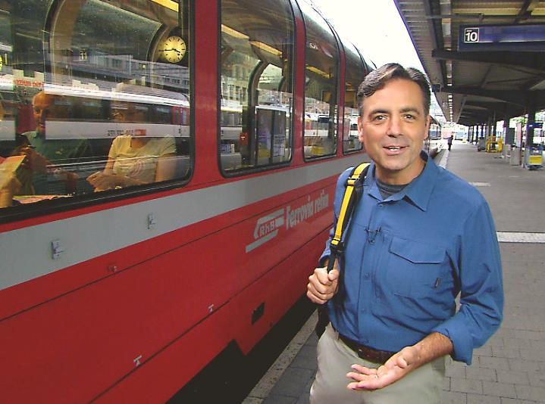
Jeff Wilson, host of Real Rail Adventures: Switzerland, prepares to board the Albula-Bernina Panoramic Railway in Chur, Switzerland. Jeff’s mission in this hour-long public television documentary is to discover why the Swiss—and countless others around the globe—love trains. The awe and wonder of the Alps exhilarate travelers and the engineering marvels of mountain railways mesmerize. Majesty and machines join in Switzerland and in Real Rail Adventures: Switzerland, a new television special from American Public Television. HD images from Emmy Award-winning photographers showcase the construction marvels and visual splendors of the Swiss rail system. From world-class main lines, to stunning scenic routes, to pioneering steam locomotives and historic cog trains, Jeff and in Real Rail Adventures: Switzerland celebrate the triumphs of Swiss engineering over unbelievably challenging terrain. Co-produced by Small World Productions and KCTS/Seattle, Real Rail Adventures: Switzerland is distributed nationally in the U.S. by APT Exchange.

Photos and press kit documents may be downloaded from www.RealRailTV.com

| Travel Apparel Provided by Columbia Sportswear| www.Columbia.com |

