Real Rail Adventures: Swiss Winter Magic, a new one-hour special from American Public Television, will air on _________ (station) _________________ at (time) _______, (day) __________ (date) _________. Hosted by Jeff Wilson, Real Rail Adventures: Swiss Winter Magic is the latest in a series of award-winning public television travel documentaries from Small World Productions of Seattle. Cascade Public Media / KCTS Seattle is the co-producer and presenting station to APT Exchange, the national distributor.
The adventures continue with winter routes, new destinations, and more Swiss splendors.
This time host Jeff Wilson highlights Swiss Winter Magic, as he models how to take the world’s best trains to grand winter adventures, including Alpine and cross-country skiing, snow-kiting, bobsledding, fat-tire biking, snowshoeing and more. Along the way, stopovers reveal remarkable stories, daily traditions and historic villages.

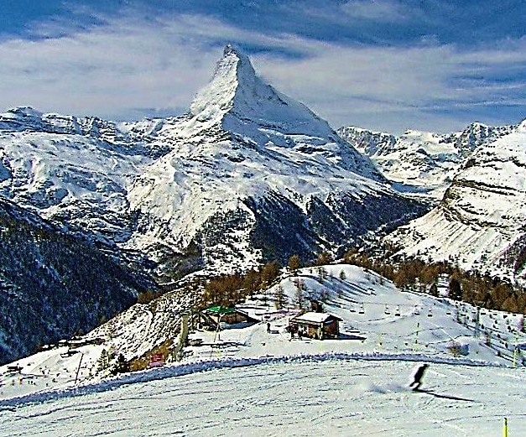
From Zurich International, Jeff boards the Intercity Line at the airport train station and heads east. At Chur, he changes to the renowned Albula Bernina Line and savors the winter scenes that scroll by on the ride to his first destination. St. Moritz is legendary as the original and premier ski resort. Alpine winter tourism was invented here in 1864 and St. Moritz has twice hosted the Winter Olympics. Naturally, Jeff hits the slopes, and discovers a wealth of options for downhill skiers of all abilities. The village is ringed by multiple ski areas that are easily accessible by trains, state-of-the-art gondolas and lifts. All serve up immaculate ski runs and amenities that delight.

For adrenaline pumping adventure, Jeff chooses tandem snow-kiting and bobsledding. He joins hardy thrillseekers to skim frozen Lake Silvaplana, whisked along by colorful snow-kites billowing in the wind: definitely Swiss Winter Magic! A four-man bobsled ups the ante even more. Riding with a professional driver and brakeman, Jeff thunders down a mile-long ice chute—the Olympia Bob Run—in just 75 seconds at a breathtaking 83 mph!

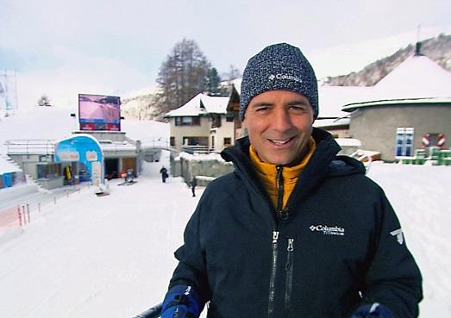
Back in town, travelers enjoy great food and top-notch accommodations. St. Moritz restaurants serve up traditional Swiss fare, casual meals, or elegant haute cuisine to satisfy even the most demanding palates.

Heading west, scenic wonders and snowscapes flood the panoramic windows of the Glacier Express on the way to the village of Reckingen in the Goms Valley. Locals cherish this area in the Upper Valais for its cross-country skiing—some of Switzerland’s best. Jeff’s objective is a readily accessible cross-country run that parallels a classic narrow-gauge railway. Powder white landscapes abound and hourly trains return skiers to the village in a snap. Goms is a prime winter hiking destination as well. Carefully-groomed trails link multiple snow-covered villages, some dating to the 17th and 18th centuries. Of the beaten tourist track, Goms is a revelation for seekers of Swiss Winter Magic.

Back aboard the Glacier Express, Jeff is headed to the village of Zermatt and the world-famous Matterhorn. Romantic, car-free Zermatt pulses year round and is particularly enchanting in winter. Scores of 500-year-old houses line the streets of the compact village. Zermatt nestles in a peaceful, yet wild, mountain world at the foot of the indomitable Matterhorn.

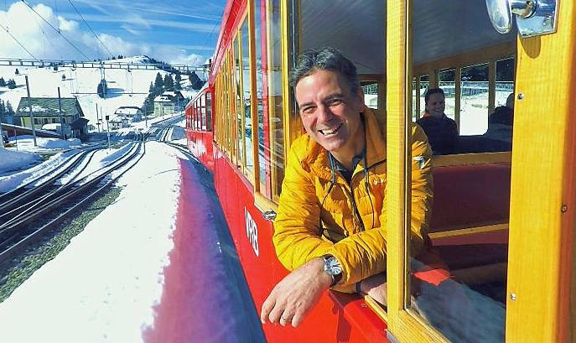
Blue skies are Jeff’s cue to hit the slopes. A cable car whisks him up the Rothorn for hours of sun-splashed skiing at its best. Eye-popping views of the Matterhorn add to the magic. Then, still buzzing from runs he won’t soon forget, Jeff relaxes at the only ski-in ski-out resort in Zermatt. Cervo practices the fine art of après-ski: Swiss hors d'oeuvres, local libations and remarkable bands—live of course. Contented skiers from around the globe join the merrymaking. Away from the tourist crowds, Jeff is beguiled by baby lambs at a blacknose sheep farm, and he sets out to become a temporary local with an alphorn lesson. Finally, he checks out Air Zermatt, a state-of-the-art helicopter rescue and sightseeing company based in the village.

Heading north, Jeff links up with the Golden Pass Panoramic VIP Train in Montreux. His destination: Gstaad, a long-famous jet-setter hangout. It was dubbed the ‘last paradise in a crazy world’ by actress Julie Andrews, a regular visitor. Known for over-the-top resorts, elegant shopping and fine dining, Gstaad still retains a genuine Alpine way of life. Jeff tries his hand at fat-tire winter biking, and declares, ’It’s a hoot but not as easy as it looks.’ Next, he checks out the lifestyle of the fabulously wealthy at the Alpina Hotel, an opulent five-star resort, said to be a favorite of celebrities including Madonna and Quentin Tarantino. Back in the village, culture is on the menu. A renowned local artist demonstrates paper cutting, a particularly Swiss art form. The next day, Jeff braves a blizzard at Glacier 3000 for a perilous trek over the Tissot Peak Walk Suspension Bridge. He survives near white-out conditions (phew!) and is rewarded with a memorable story to tell back home.

A 90-minute train ride delivers Jeff back to Zurich. His agenda includes a jaunt to the top of Uetliberg, ‘Zurich’s mountain,’ 2500 feet above the city, and time to wander the cobbled streets, shops and cabarets of Old Town. A walking tour of West Zurich rounds out his urban interlude. Here young artists have reclaimed warehouses and factories, injecting new creative energy into stately Zurich.

Up next: an Art Nouveau steamboat to Vitznau and a cogwheel train to the top of Rigi Kulm, perched high above Lake Lucerne. Jeff relishes snowshoeing, savors an ‘oh-so-Swiss’ fondue lunch, and relaxes at a luxurious spa designed by Mario Botta. Finally to cap this great adventure, Jeff paraglides off the mountain top to a village far below. Conditions are perfect as he launches into the wind and soars high over the Alps: a fitting end to Swiss Winter Magic.

HD images from Emmy Award-winning photographers sweep viewers into virtual adventures aboard the world’s best rail system. Amazing trains, scenic grandeur, historic perspective and concise travel advice mesh seamlessly. And there are Swiss trains aplenty—new and old, big and small, breathtaking and efficient on Real Rail Adventures: Swiss Winter Magic.

# # #

Contact: John Givens | johngivens@travelsmallworld.com | 206.329.7167

