Real Rail Adventures: Swiss Winter Magic
with Jeff Wilson

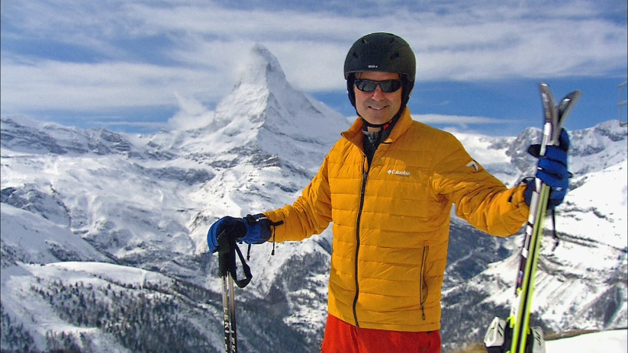
Real Rail Adventures: Swiss Winter Magic host Jeff Wilson prepares for ‘the ski run of a lifetime’ in the shadow of the Matterhorn above Zermatt Switzerland. In this all new hour-long documentary, Wilson models how to take the world’s best trains to grand winter adventures. From Alpine and cross-country skiing, to snow-kiting, bobsledding, fat-tire biking, and more, Wilson spotlights winter thrills, scenic splendors and up-to-date travel advice. Jeff’s stopovers reveal remarkable stories, daily traditions and historic villages.

Real Rail Adventures: Swiss Winter Magic destinations include: Chur, St. Moritz, the Goms Region, Zermatt and the Matterhorn, Gstaad, Zurich, and Mount Rigi. Featured rail lines include: Albula-Bernina Railway, the Glacier Express, The Vitznau-Rigi Bahn, and the Montreux-Oberland Bernois Railway, known as the Golden Pass Line. Real Rail Adventures: Swiss Winter Magic is co-produced by Small World Productions and Cascade Public Media / KCTS Seattle, and is distributed nationally by American Public Television
Exchange.

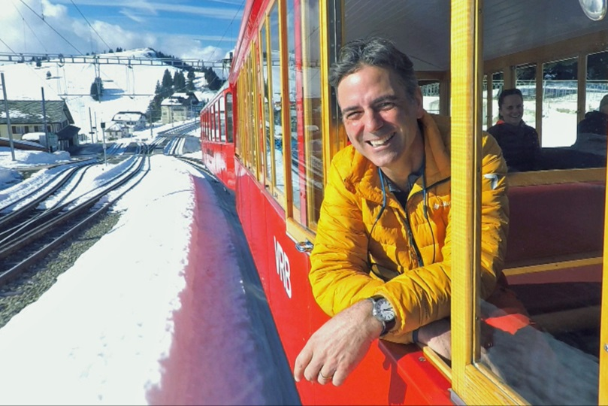
Jeff Wilson, host of Real Rail Adventures: Swiss Winter Magic, revels in wintertime fun aboard the Vitznau Rigi Bahn cog-railway on his way to the top of Mount Rigi. Jeff’s adventures continue in the third episode of this Telly Award-winning series with winter destinations, outdoor sports and Swiss trains aplenty—new and old, big and small, breathtaking and efficient.

Winter grandeur is on full display in this new hour-long special as Jeff models how-to take the world’s best trains to grand winter adventures, from Alpine and cross-country skiing, to snow-kiting, bobsledding, fat-tire biking, snowshoeing and more. Along the way, Jeff’s stopovers reveal remarkable stories, daily traditions and historic villages.

From world-class mainlines to stunning scenic routes Real Rail Adventures: Swiss Winter Magic celebrates the country’s state-of-the art rail system crisscrossing unbelievably challenging terrain. Co-produced by Small World Productions and Cascade Public Media / KCTS Seattle, Real Rail Adventures: Swiss Winter Magic is distributed nationally by American Public Television
Exchange.

|Photos and press kit documents may be downloaded from www.RealRailTV.com
| Jeff’s Travel Apparel Provided by Columbia Sportswear| www.Columbia.com

